1.How are inline and block elements different from each other?

Inline element does not starts with a new line while the block elements start with a new line .
Inline element does not take up the full width available on the page while the block elements take up the full width available on the page.
Inline element include the following tags
<span>,<button>,<sub>,<sup> etc.
Block element include the following tags
<div>,<form>,<table> etc

2.Explain the difference between visibility:hidden and display:none
Hiding an element can be done by setting the display property to none. The element will be hidden, and the page will be displayed as if the element is not there
<!DOCTYPE html>
<html>
<head>
<style>
h1.hidden {
display: none;
}
</style>
</head>
<body>

<h1>This is a visible heading</h1>
<h1 class="hidden">This is a hidden heading</h1>
<p> display: none; does not take up any space.</p>

</body>
</html>

This is a visible heading
visibility:hidden also hides an element and will take up space of that element.
<!DOCTYPE html>
<html>
<head>
<style>
h1.hidden {
visibility: hidden;
}
</style>
</head>
<body>

<h1>This is a visible heading</h1>
<h1 class="hidden">This is a hidden heading</h1>
<p>The hidden heading takes up space.</p>

</body>
</html>

3. Explain the clear and float properties.
The CSS float property specifies how an element should float while the CSS clear property specifies what elements can float beside the cleared element and on which side.

The float property is used for formatting content .
The float property can have one of the following values:
- left - The element floats to the left of its container.
- right- The element floats to the right of its container.
- none - This is default .
- inherit - The element inherits the float value of its parent .

4. explain difference between absolute, relative,fixed and static.
The css position property defines how the element is positioned on the webpage.
- Static - This is the default value, all elements are in order as they appear in the document.
- Relative - The element is positioned relative to its normal position.
- Absolute - The element is positioned absolutely to its first positioned parent.
- Fixed - The element is positioned related to the browser window.

5. Write the HTML code to create a table in which there are 4 columns( ID , Employee Name, Designation, Department) and at least 6 rows. Also do some styling to it.
<!DOCTYPE html>
<html lang="en">
<head>
<meta charset="UTF-8">
<title>Title</title>
<style>
table, td {
border: 1px solid black;
}
th
{
border: 2px;
color: blue;
background-color: brown;
}
td{
border-style:inset;
color: chartreuse;
}
</style>
</head>
<body>
<table style="width:100%">
<tr>
<th>ID</th>
<th>Employee Name</th>
<th>Designation</th>
<th>Department</th>
</tr>
<tr>
<td>1</td>
<td>Smith</td>
<td>clerk</td>
<td>Accounts</td>
</tr>
<tr>
<td>2</td>
<td>Sanjay</td>
<td>SR.Manager</td>
<td>IT</td>
</tr>
<tr>
<td>3</td>
<td>Anurag</td>
<td>QualityAnalyst</td>
<td>IT</td>
</tr>
<tr>
<td>4</td>
<td>Aliya</td>
<td>SeniorConsultant</td>
<td>HR</td>
</tr>
<tr>
<td>5</td>
<td>Jack</td>
<td>Manager</td>
<td>Marketing</td>
</tr>
<tr>
<td>6</td>
<td>abc</td>
<td>Engineer</td>
<td>Design</td>
</tr>
</table>
</body>
</html>

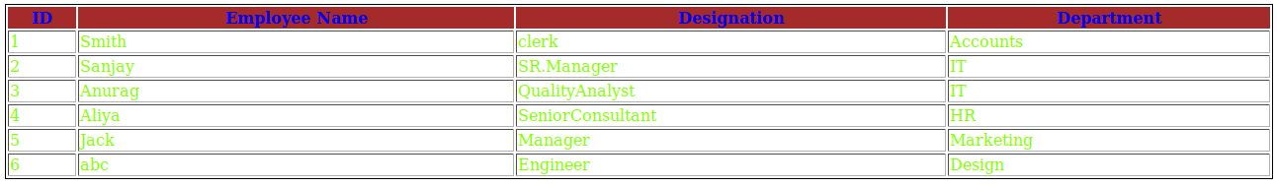

6. Why do we use meta tags?
The <meta> tag provides metadata about HTML document. Metadata is not displayed on the page.
Meta elements are typically used to specify page description, keywords, author of the document, last modified, and other metadata.
<meta> tags are always written inside the <head> element.Meta tag takes values as name/value pairs.
Through this tag html5 introduced a method to take control over the viewport.
<meta name="viewport" content="width=device-width, initial-scale=1.0">

7. Explain box model.
In html all the elements are considered as boxes.It is usded for design and layout.
It consists of margin,padding,borders and the actual content.

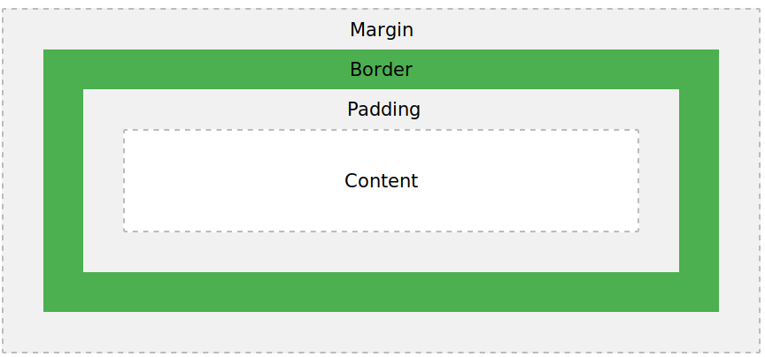
div {
width: 30px;
border: 20px solid blue;
padding: 15px;
margin: 15px;
}

What are the different types of CSS Selectors?
Selectors are used in css in styling .Selectors are just like the patterns that are used to select the element to get them style.
Some selectors are :
.class: Select all the elements with the class.
<style>
.box
{
position: absolute;
left: 30%;
transform: translateX(50%) ;
}
<style>
<form class="box">

#id : Select the element with the defined id.

<style>
#box
{
position: absolute;
left: 30%;
transform: translateX(50%) ;
}
<form id = “box”>

* : Selects all the elements

* {
background-color: black;
}

element,element : Example table,td :so it selects all <table> elements and <td> elements.

table, td {
border: 1px solid black;
}

9. Define Doctype.
Doctype declaration is not a declaration tag but an instruction to web browser about the version of HTML page.
We should always add <!DOCTYPE> declaration to our HTML document, in order to tell the browser what type of document we are expecting.It is not case sensitive.

<!DOCTYPE html>
<html lang="en">
<head>
<meta charset="UTF-8">
<title>showing doctype</title>
</head>
<body>
</body>
</html>

10. Explain 5 HTML5 semantic tags.

Semantic tags are used to define its meaning to the developer as well as browser.
Example: table,form,article etc.

New semantic elements introduced by html5 are

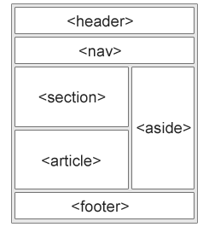

Some examples of semantic tags are:

- <section> : This tag defines section in a document.

<!DOCTYPE html>
<html lang="en">
<head>
<meta charset="UTF-8">
<title>showing doctype</title>
</head>
<body>
<section>
<h1>this is 1st</h1>
<p>Hi i am first one </p>
</section>
<section>
<h1>this is 2nd</h1>
<p>hi i am second section</p>
</section>
</body>
</html>
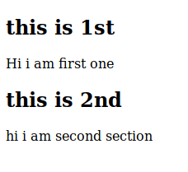

- Header element specifies the header of the document.
- Footer element specifies the footer of the document.
<!DOCTYPE html>
<html lang="en">
<head>
<meta charset="UTF-8">
<title>showing doctype</title>
</head>
<body>
<header>
<h1>Semantic tags</h1>
<p>to show example</p>
</header>
<p>
We found no JetBrains product licenses associated with your JetBrains Account. You can:
Purchase product license(s)
Link your past purchases to your account
Contact the person who manages commercial licenses in your company and request an invitation to use them
Apply for a free student or teacher license for educational purposes
</p>
<footer>
<p>Posted by: sj</p>
</footer>
</body>
</html>

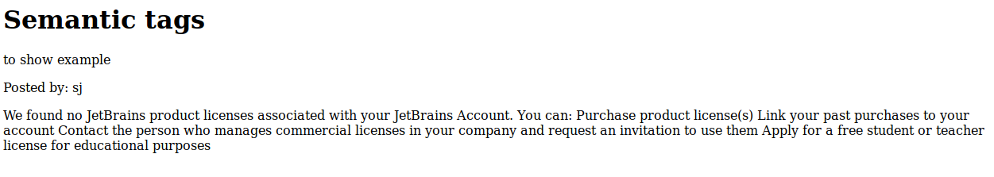

- Nav tag is used to define a set of navigation links.

<!DOCTYPE html>
<html lang="en">
<head>
<meta charset="UTF-8">
<title>showing doctype</title>
</head>
<body>
<nav>
<a href="/html/">HTML</a> |
<a href="/css/">CSS</a> |
<a href="/js/">JavaScript</a> |
<a href="/jquery/">jQuery</a>
</nav>
</body>
</html>

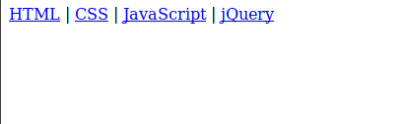

11. Create HTML for web-page.jpg (check resources, highest weightage for answers)
12. Create HTML for form.png (check resources, highest weightage for answers)

